GEC Xpress

Software Requirements Specification

V0.1

Prepared for
GEC Raipur

Revision History

Date | Description | Author | Comments

Document Approval

The following Software Requirements Specification has been accepted and approved by the following:
Signature | Printed Name | Title | Date

Table of Contents
Revision History ii
Document Approval ii
1. Introduction 1
1.1 Purpose 1
1.2 Scope 1
1.3 Definitions, Acronyms, and Abbreviations 1
This section describes the terminologies used in this SRS documentation to help reader clearly understand the functionalities of the project. 1
2. General Description 2
2.1 Product Functions 2
2.2 User Characteristics 2
2.3 Assumptions and Dependencies 2
3. Specific Requirements 2
3.1 External Interface Requirements 2
3.1.1 User Interfaces 2
3.1.2 Software Interfaces 2
3.2 Functional Requirements – for User 2
3.2.1 SIGNUP 2
3.2.2 LOGIN 3
3.2.3 LIST DEPARTMENTS 3
3.2.4 DEPARTMENTS INFORMATION 4
3.2.5 DEPARTMENTS INFORMATION 4
3.2.6 ISSUE REPORTING 5
3.2.7 FEEDBACK 5
3.2.8 USER INFORMATION 6
3.3 Functional Requirements – for Admin 6
3.3.1 LOGIN 6
3.3.2 EDIT DEPARTMENTS 6
3.3.3 EDIT DEPARTMENTS INFORMATION 7
3.3.4 VIEW ISSUE 7
3.3.5 VIEW FEEDBACK 8
3.3.6 REPLY ISSUE 8
3.3.7 REPLY FEEDBACK 9
3.3.8 ADMIN INFORMATION 9
3.4 Use Cases 10
3.4.1 Use Case #1 10
3.4.2 USER STORIES 10
3.4.3 Use Case #2 11
3.4.4 USER STORIES - ADMIN 12
4. Analysis Models 12
4.1 Data Flow Diagrams (DFD) 12

1. Introduction
It is a comprehensive student information management system to allow the students to know the latest news in the department and to give feedback to the department. It has a simple UI and is intuitive. Student can view departments, department details, send feedback, report issues to department thus enabling easy collaboration and supporting the daily operations of the institution.

1.1 Purpose
To provide information about his/her department and to be in communication with his/her respective department.

1.2 Scope
- It displays the information of the departments of a school, like news, department information etc.
- User can report an issue with a photograph, and even give a feedback about school.

1.3 Definitions, Acronyms, and Abbreviations

This section describes the terminologies used in this SRS documentation to help reader clearly understand the functionalities of the project.
Product functions – they describe the major functions that the software will perform.
User characteristics – they describe the requirements of the users of the product.
Assumptions and dependencies – basic dependencies in the form of knowledge, software or hardware.
Functionality requirements – detailed description of the functions the software is expected to perform.
Use case – a graphical description of the interaction between the elements in the system.
Data flow diagrams – a graphical representation of the flow of data through the information system.

2. General Description

2.1 Product Functions
This application has signup, login, list departments, department’s news list, report issue, give feedback, viewing his/her own information functions

2.2 User Characteristics
The users here refers to students. Students can view their respective department information, and report it and give a feedback also.

2.3 Assumptions and Dependencies
User should have knowledge of using android phone.
User should have an android smartphone with OS version = 4.0 [ICS]

3. Specific Requirements

3.1 External Interface Requirements

3.1.1 User Interfaces
WEB UX/ Wireframes
Mobile UX Wireframes

3.1.2 Software Interfaces

3.2 Functional Requirements – for User

3.2.1 SIGNUP
3.2.1.1 Introduction
Users are requested to signup once with their mobile number, which will be used to identify their accounts.
3.2.1.2 Inputs
Inputs are mobile number, otp.
3.2.1.3 Processing
Once user submits the phone number an OTP(one time password), will be sent to given mobile number, which verifies valid user. If sent OTP and received OTP, if matches login the user.
3.2.1.4 Outputs
If signup success, success message is displayed, else failure message will be displayed.
3.2.1.5 Error Handling
For any other failures like server error, DB error, parse error, failure–try again message will be displayed.

3.2.2 LOGIN
3.2.2.1 Introduction
Users are requested to login with their mobile number, which will be used to identify their accounts.
3.2.2.2 Inputs
Inputs are mobile number.
3.2.2.3 Processing
When user submits the phone number, which verifies valid user, if matches mobile number in database then login the user.
3.2.2.4 Outputs
If login success, success message is displayed, else failure message will be displayed.
3.2.2.5 Error Handling
For any other failures like server error, DB error, parse error, failure–try again message will be displayed.

3.2.3 LIST DEPARTMENTS
3.2.3.1 Introduction
Once user login with their mobile number, their respective departments list will be shown.
3.2.3.2 Inputs
Inputs are mobile number.
3.2.3.3 Processing
Based on logged in user mobile number, his/her respective departments will be displayed.

3.2.3.4 Outputs
If departments exists for that user, displays department list, else failure message will be displayed.
3.2.3.5 Error Handling
For any other failures like server error, DB error, parse error, failure–try again message will be displayed.

3.2.4 DEPARTMENTS INFORMATION
3.2.4.1 Introduction
Once user selects a department, that respective department’s information will be shown.
3.2.4.2 Inputs
Inputs are mobile number, Department_id.
3.2.4.3 Processing
Based on logged in user mobile number and his/her respective department_id selected, respective information will be displayed.
3.2.4.4 Outputs
If department exists for that id, displays department Info, else failure message will be displayed.
3.2.4.5 Error Handling
For any other failures like server error, DB error, parse error, failure–try again message will be displayed.

3.2.5 DEPARTMENTS INFORMATION
3.2.5.1 Introduction
Once user selects a department, that respective department’s information will be shown.
3.2.5.2 Inputs
Inputs are mobile number, department_id.
3.2.5.3 Processing
Based on logged in user mobile number and his/her respective department_id selected, respective information will be displayed.

3.2.5.4 Outputs
If department exists for that id, displays department Info, else failure message will be
displayed.
3.2.5.5 Error Handling
For any other failures like server error, DB error, parse error, failure–try again message will be displayed.

3.2.6 ISSUE REPORTING
3.2.6.1 Introduction
Once user logged in, user can report an issue to with or without a photo of it.
3.2.6.2 Inputs
Inputs are mobile number, photo and description.
3.2.6.3 Processing
Based on logged in user mobile number and his/her respective issue report will be saved.
3.2.6.4 Outputs
If report saved for that mobile, displays success message, else failure message will be displayed.
3.2.6.5 Error Handling
For any other failures like server error, DB error, parse error, failure–try again message will be displayed.

3.2.7 FEEDBACK
3.2.7.1 Introduction
Once user logged in, user can give feedback about school or school’s activity.
3.2.7.2 Inputs
Inputs are mobile number, feedback description.
3.2.7.3 Processing
Based on logged in user mobile number and his/her respective feedback will be saved.
3.2.7.4 Outputs
If feedback saved for that mobile, displays success message, else failure message will be displayed.

3.2.7.5 Error Handling
For any other failures like server error, DB error, parse error, failure–try again message will be displayed.

3.2.8 USER INFORMATION
3.2.8.1 Introduction
Once user logged in, his/her information will be shown.
3.2.8.2 Inputs
Inputs are mobile number.
3.2.8.3 Processing
Based on logged in user mobile number and his/her respective information will be displayed.
3.2.8.4 Outputs
If information exists for that id, displays user Info, else failure message will be displayed.
3.2.8.5 Error Handling

3.3 Functional Requirements – for Admin

3.3.1 LOGIN
3.3.1.1 Introduction
Admins are requested to login with their mobile number, which will be used to identify their accounts.
3.3.1.2 Inputs
Inputs are mobile number.
3.3.1.3 Processing
When admin submits the phone number, which verifies valid admin user, if matches mobile number in database then login the user.
3.3.1.4 Outputs
If login success, success message is displayed, else failure message will be displayed.
3.3.1.5 Error Handling
For any other failures like server error, DB error, parse error, failure–try again message will be displayed.

3.3.2 EDIT DEPARTMENTS
3.3.2.1 Introduction
Once admin login with their mobile number, they must be able to edit departments.
3.3.2.2 Inputs
Inputs are mobile number, Department_id.
3.3.2.3 Processing
Based on logged in user mobile number, his/her respective departments will be displayed which is editable for admin.
3.3.2.4 Outputs
If departments exists for that user, displays department list, else failure message will be displayed.
3.3.2.5 Error Handling
For any other failures like server error, DB error, parse error, failure–try again message will be displayed.

3.3.3 EDIT DEPARTMENTS INFORMATION
3.3.3.1 Introduction
Once admin selects a department, that respective department’s information will be shown. Additionally, admin will have the privilege to edit department information.
3.3.3.2 Inputs
Inputs are mobile number, Department_id.
3.3.3.3 Processing
Based on logged in user mobile number and his/her respective department_id selected, respective information will be displayed and its editable.
3.3.3.4 Outputs
If department exists for that id, displays department Info, else failure message will be displayed.
3.3.3.5 Error Handling
For any other failures like server error, DB error, parse error, failure–try again message will be displayed.

3.3.4 VIEW ISSUE
3.3.4.1 Introduction
Once admin is logged in, admin can view the reported issue.
3.3.4.2 Inputs
Inputs are mobile number, department_id
3.3.4.3 Processing
Based on logged in admin ID, he can view the issue report.
3.3.4.4 Outputs
If report saved for that mobile, displays success message, else failure message will be displayed.
3.3.4.5 Error Handling
For any other failures like server error, DB error, parse error, failure–try again message will be displayed.

3.3.5 VIEW FEEDBACK
3.3.5.1 Introduction
Once admin is logged in, admin can view the reported feedback.
3.3.5.2 Inputs
Inputs are mobile number, department_id
3.3.5.3 Processing
Based on logged in user mobile number and his/her respective feedback will be saved.
3.3.5.4 Outputs
If feedback saved for that mobile, displays success message, else failure message will be displayed.
3.3.5.5 Error Handling
For any other failures like server error, DB error, parse error, failure–try again message will be displayed.

3.3.6 REPLY ISSUE
3.3.6.1 Introduction
Once admin is logged in, admin can reply the reported issue.

3.3.6.2 Inputs
Inputs are mobile number, description of reply
3.3.6.3 Processing
Based on logged in admin ID, he can reply the issue report.
3.3.6.4 Outputs
If reply saved for that mobile, displays success message, else failure message will be displayed.
3.3.6.5 Error Handling
For any other failures like server error, DB error, parse error, failure–try again message will be displayed.

3.3.7 REPLY FEEDBACK
3.3.7.1 Introduction
Once admin is logged in, admin can reply the reported feedback.
3.3.7.2 Inputs
Inputs are mobile number, description of reply
3.3.7.3 Processing
Based on logged in admin ID, he can reply the feedback.
3.3.7.4 Outputs
If reply saved for that mobile, displays success message, else failure message will be displayed.
3.3.7.5 Error Handling
For any other failures like server error, DB error, parse error, failure–try again message will be displayed.

3.3.8 ADMIN INFORMATION
3.3.8.1 Introduction
Once admin logged in, his/her information will be shown.
3.3.8.2 Inputs
Inputs are mobile number.
3.3.8.3 Processing
Based on logged in user mobile number and his/her respective information will be displayed.

3.3.8.4 Outputs
If information exists for that id, displays user Info, else failure message will be displayed.

3.3.8.5 Error Handling
For any other failures like server error, DB error, parse error, failure–try again message will be displayed.

3.4 Use Cases

3.4.1 Use Case #Mobile and web application
Sign Up

Login

View Department

View Dept info

Report an issue
User

Feedback

News portal

3.4.2 USER STORIES

SIGNUP:
As a user, I must be able to sign up to the website using mobile number and OTP. Signup page to contain the following fields – mobile number. Upon entering mobile number and submitting, I must get an OTP page which should validate the OTP.

LOGIN:
As a user, I must be able to login to the website using my mobile number. Upon entering the correct mobile number, I must be taken to the home page of the site.

VIEW DEPARTMENT:
As a user, I must be able to view all departments of my college.

VIEW DEPARTMENT INFORMATION:
As a user, I must be able to view department information of all department irrespective of the department to which I belong. Clicking on a particular department, must show me the news of that department.

NEWS:
As a user, I must be able to view the list of news department wise. And when I click on a particular news, I must be able to view the news in details.

REPORT AN ISSUE:
As a user, I must be able to report issues related to my department only. I must be also able to view all the issues that I have reported in the past in a columnar format.
Report issue page to contain the following fields – title of issue, description field

FEEDBACK: As a user, I must be able to report feedback related to my department only. I must be also able to view all the feedbacks that I have reported in the past in a columnar format.
Report feedback page to contain the following fields – title of issue, description field.
USER PROFILE: As a user, I must be able to view my profile details – USN, class, department, semester.

3.4.3 Use Case #2

Login

Edit Department

Edit Dept info

View reported issues
Admin

View feedback

Send response
News add/edit/delete/view

3.4.4 USER STORIES - ADMIN
LOGIN:
As an admin, I must be able to login to the website using my mobile number. Upon entering the correct mobile number, I must be taken to the home page of the site.

EDIT DEPARTMENT:
As an admin, I must be able to view and edit all departments of my college.

EDIT DEPARTMENT INFORMATION:
As a user, I must be able to edit department information of all department irrespective of the department to which I belong. Clicking on a particular department, must show me the news of that department. I must be able to post news of that particular department. Post news page to contain the following fields – title of the news, description, option to upload an image.

VIEW/RESPOND ISSUES:
As an admin, I must be able to view reported issues across all departments.
Report issue page to contain the following fields – reply button to all the issues, description

FEEDBACK:
As an admin, I must be able to respond to the feedback raised across departments. I must be also able to view all the feedbacks that I have responded to in the past in a columnar format. Respond to feedback page to contain the following fields – reply button to all the issues, description.

NEWS:
As an admin, I must be able to add the news to a particular department. I must be also able to view all the department news which have been added. I must be able to edit the news of the department and delete the news if I wish to do so.

4. Analysis Models

4.1 Data Flow Diagrams (DFD)

Admin Panel WireFrame : Login Screen

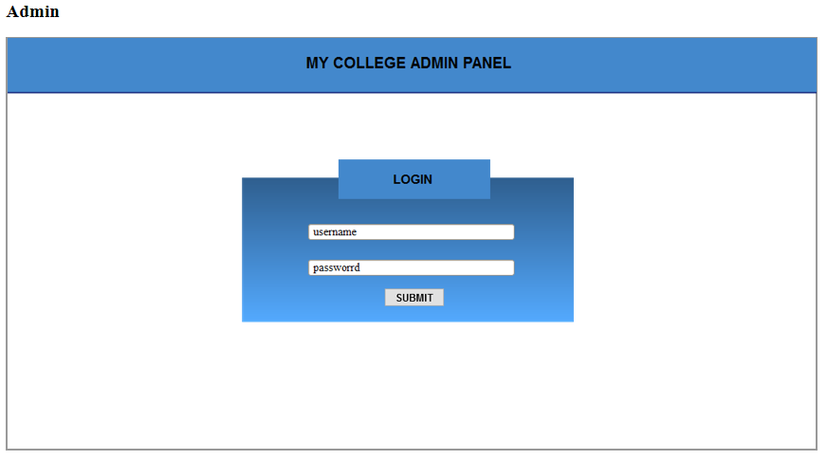

Admin Panel WireFrame : Home Screen

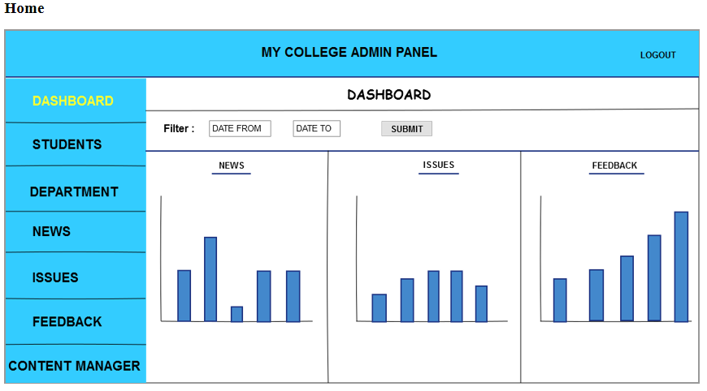

Admin Panel WireFrame : Students Screen

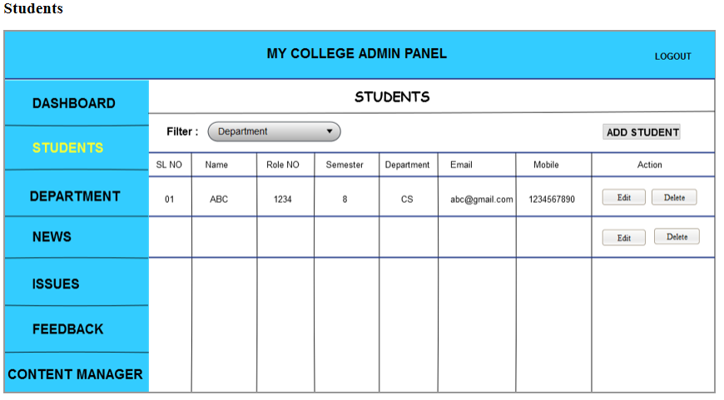

Admin Panel WireFrame : Add Student Screen

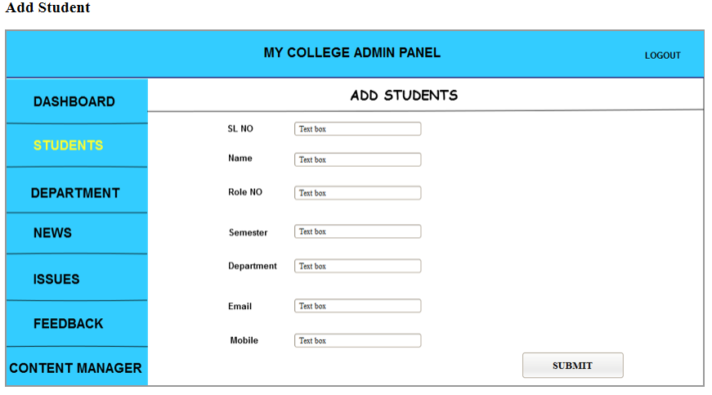

Admin Panel WireFrame : Edit Student Screen

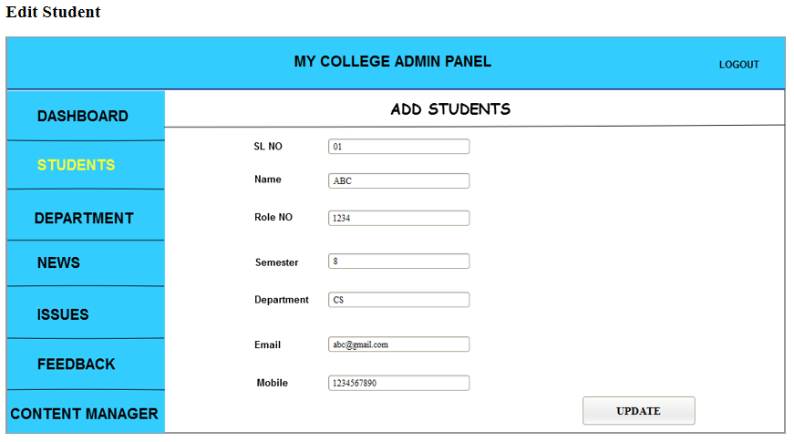

Admin Panel WireFrame : Department Screen

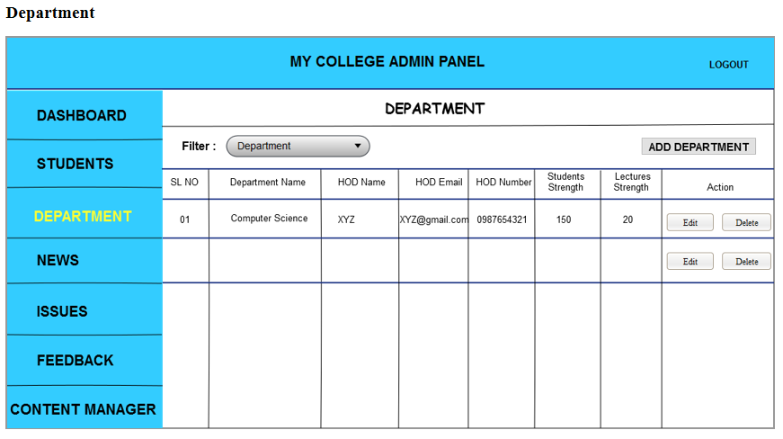

Admin Panel WireFrame : Add Department Screen

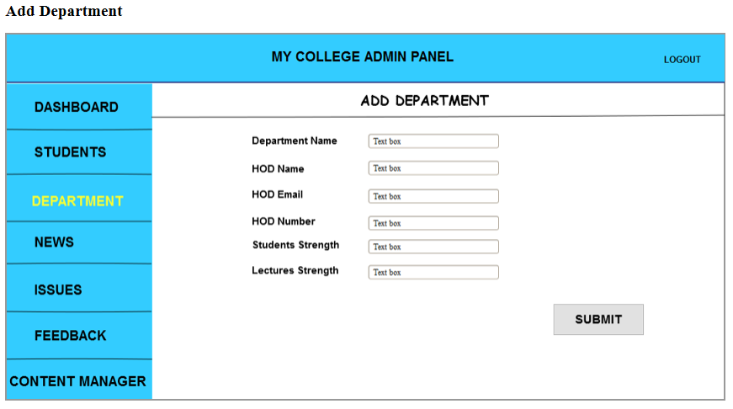

Admin Panel WireFrame : Edit Department Screen

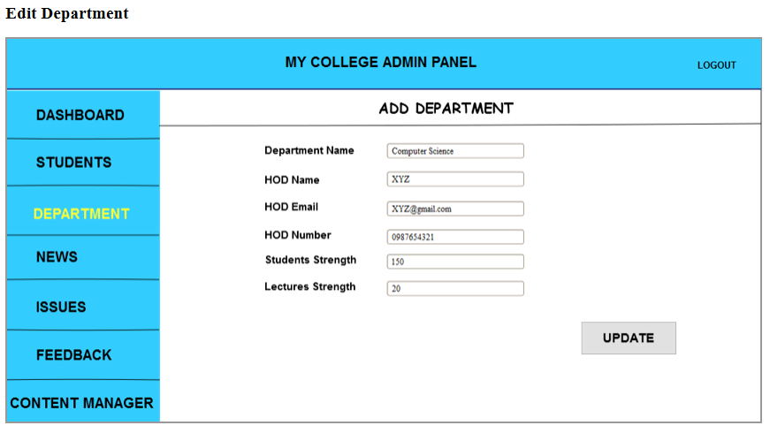

Admin Panel WireFrame : News Screen

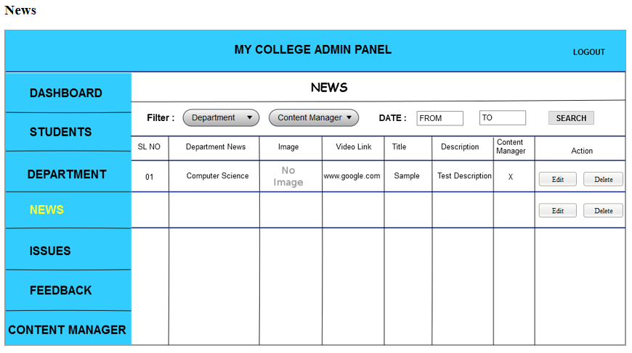

Admin Panel WireFrame : News Update Screen

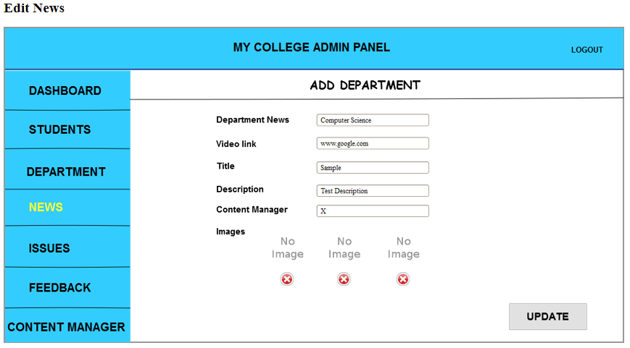

Admin Panel WireFrame : Issues Screen

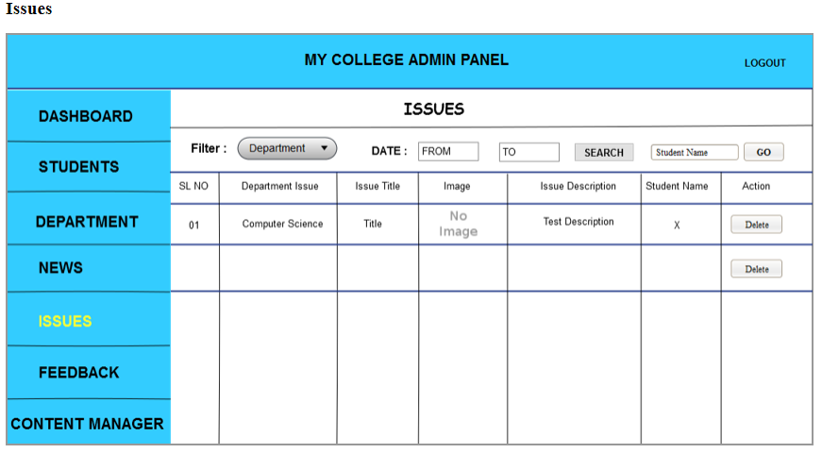

Admin Panel WireFrame : Feedback Screen

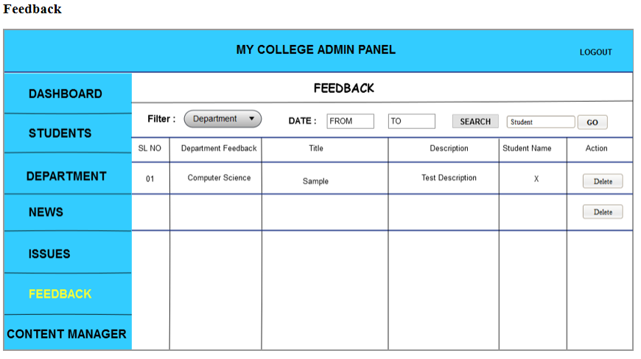

Admin Panel WireFrame : Add Content Manager Screen

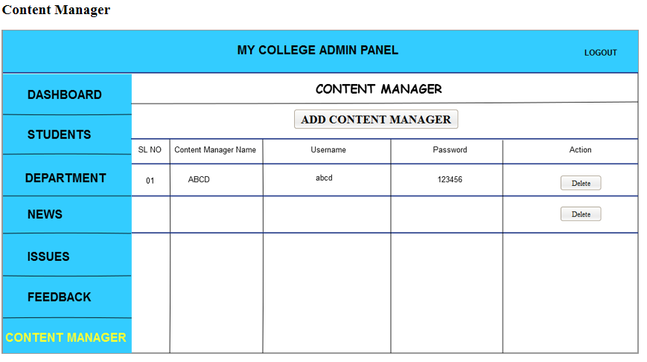

Admin Panel WireFrame : Content Manager Screen

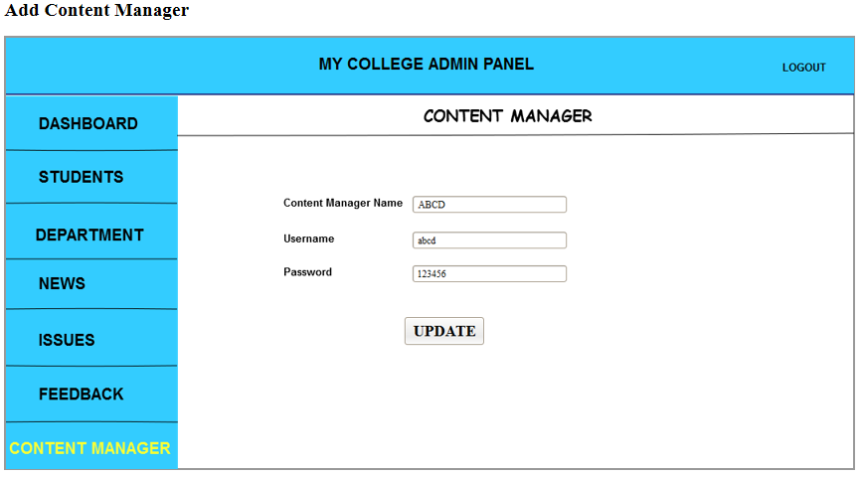

Website WireFrame : Main Screen

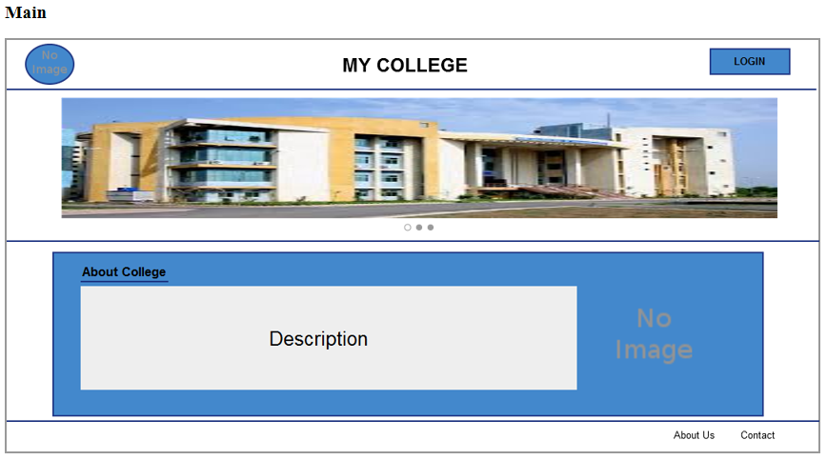

Website WireFrame : Login Screen

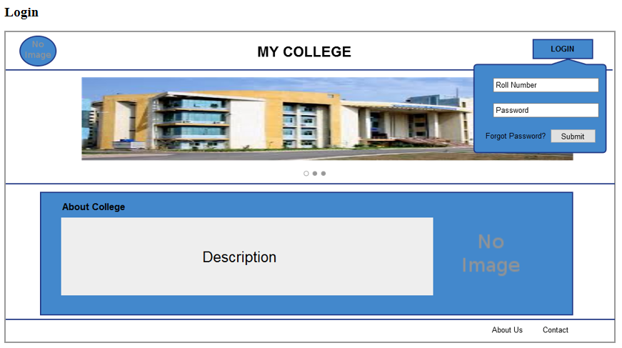

Website WireFrame : Home Screen

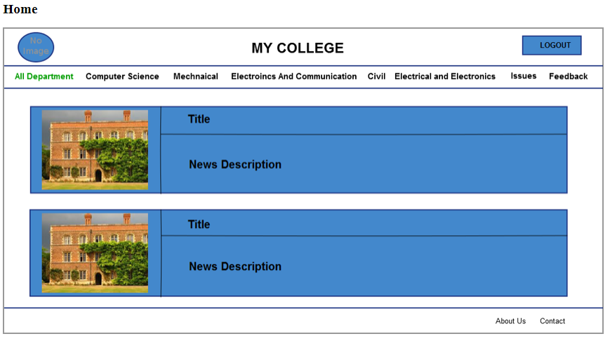

Website WireFrame : Computer Science Screen

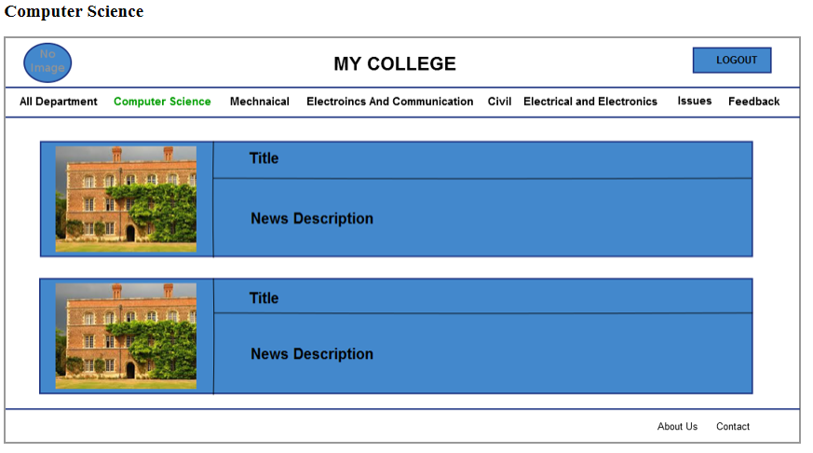

Website WireFrame : Mechnaical Screen

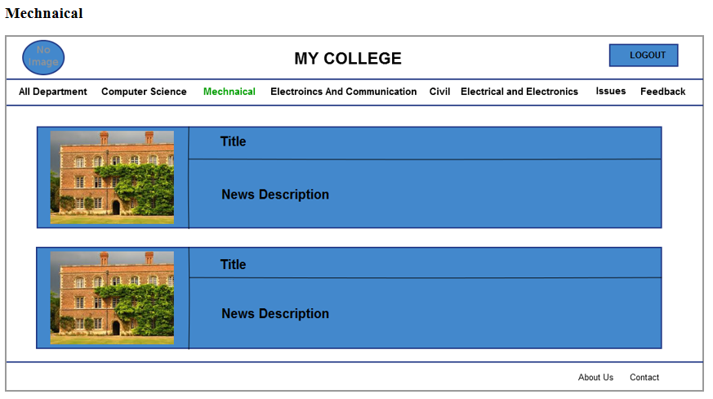

Website WireFrame : EC Screen

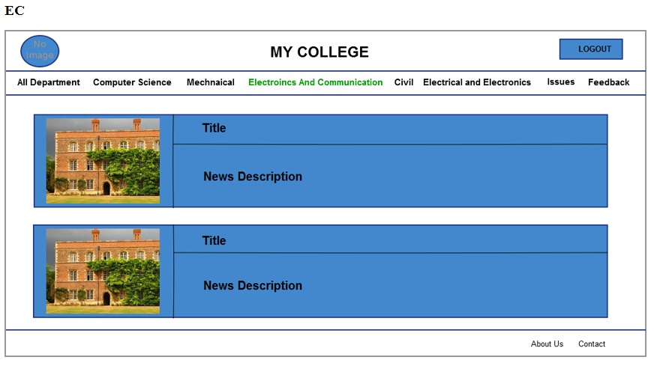

Website WireFrame : Civil Screen

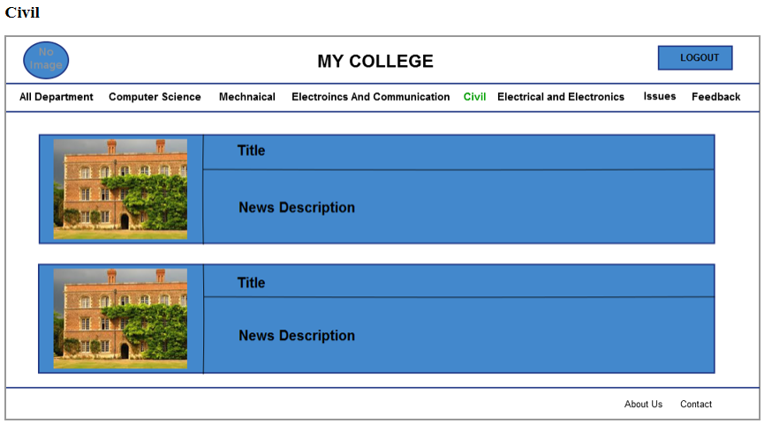

Website WireFrame : E and E Screen

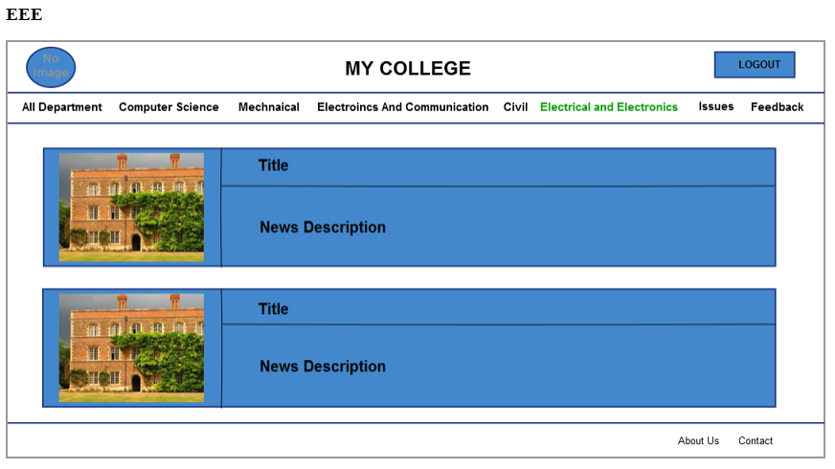

Website WireFrame : Issues Screen

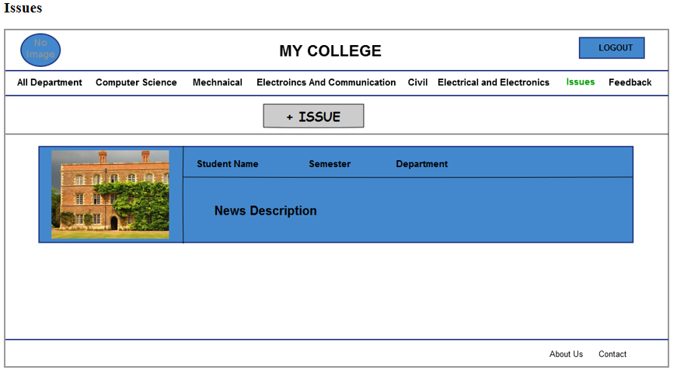

Website WireFrame : Feedback Screen

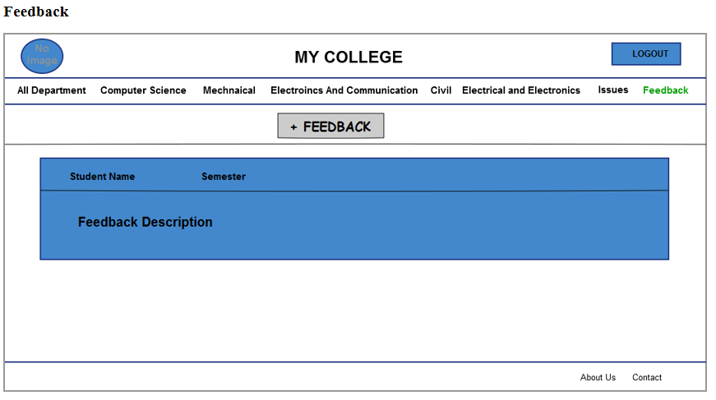

Website WireFrame : Add Issue Screen

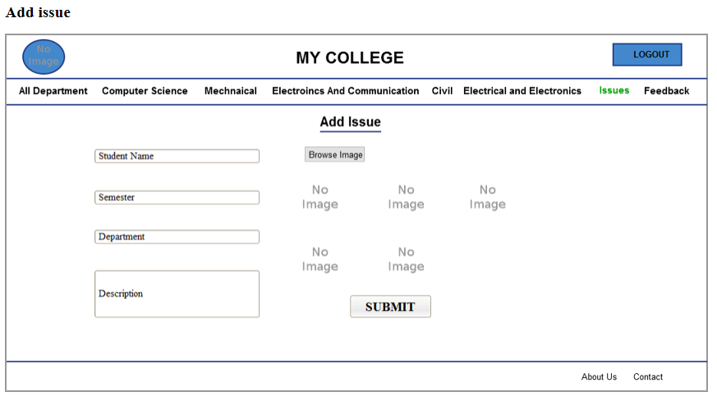

Website WireFrame : Add Feedback Screen

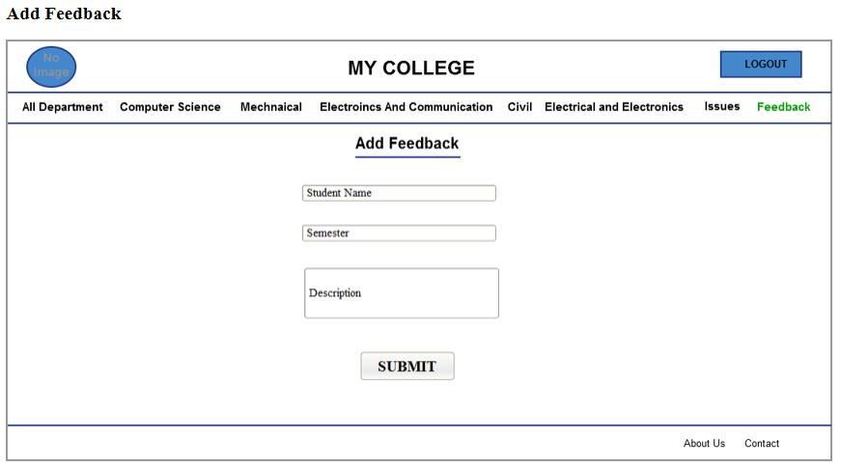

Mobile App WireFrame : Login Screen

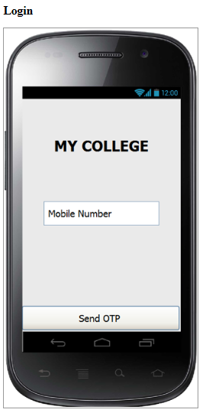

Mobile App WireFrame : Otp Screen

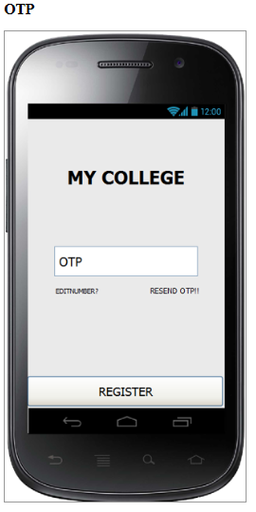

Mobile App WireFrame : Home Screen

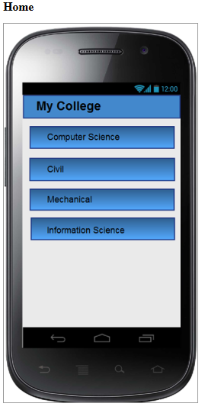

Mobile App WireFrame : News Screen

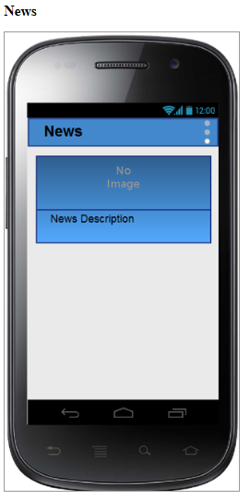

Mobile App WireFrame : Menu Screen

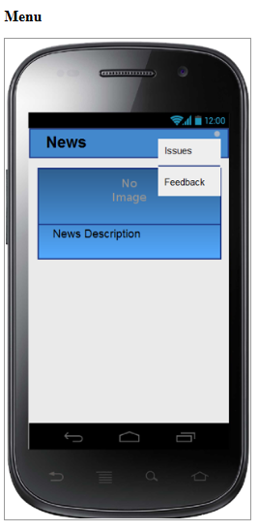

Mobile App WireFrame : Issue Screen

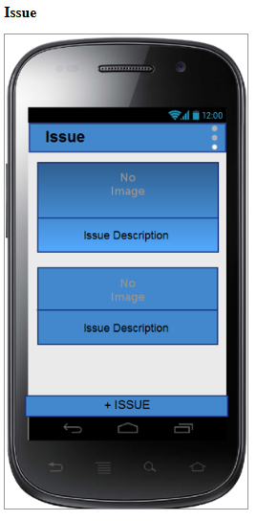

Mobile App WireFrame : Add Issue Screen

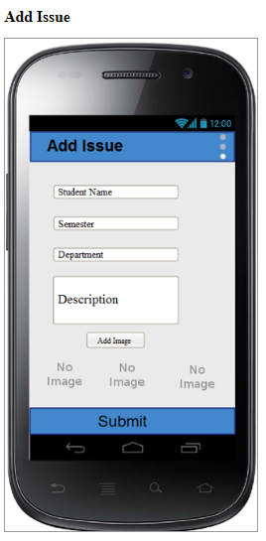

Mobile App WireFrame : Feedback Screen

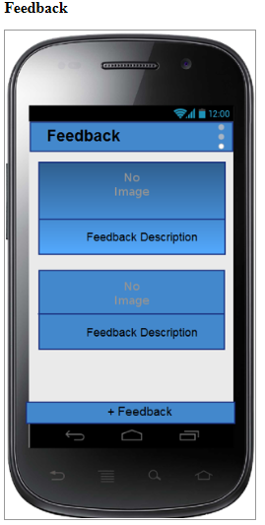

Mobile App WireFrame : Add Feedback Screen

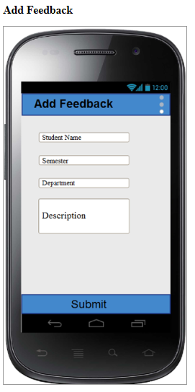

API Details : User Register

Project Details

Project Name | Version | BASE URL
GEC Xpress | v.1.0 | localhost/gecepress/

API Details

API Name | userRegister
URL | admin/api/v1.0/controller/newscontroller.php?action=userRegister
Request Id | 001
Method | POST
Description | This api is used to take the mobile number in request and if the mobile number is present in the database then a success message with the opt is send
 | and if its not present send the failure message

Request

{

"requestMessage": "userRegister", "requestId": "001", "requestData": [
{

"mobile_no": "9901027651"

}

]

}

Request Parameters

Parameter | Mandatory | Description
mobile_no |  | mobile number

Response Success

{

"requestMessage": "userRegister", "requestId": "001", "response":" success", "responseCode": "200", "resultData": [
{

"message": "An OTP is sent to your mobile... Please enter OTP sent to your mobile no.", "mobile_no":"9901027651",
"otp":"123456"

}

]

}

Response Failure

{

"requestMessage": "userRegister", "requestId": "001",
"response": "failure", "responseCode": "200", "resultData": [

{

"message": "Mobile no not found in database. Please conctact admin"

}

]

}

Response Parameters

Parameter | Mandatory | Description
message |  | success or failure mesage
mobile_no |  | mobile no
otp |  | otp

API Details : User OTP

Project Details

Project Name | Version | BASE URL
GEC Xpress | v.1.0 | localhost/gecepress/

API Details

API Name | userOTP
URL | admin/api/v1.0/controller/newscontroller.php?action=userOTP
Request Id | 002
Method | POST
Description | In this api user sends the mobile number and otp and it is validated from the back end and the success or failure message is sent back as a response

Request
{

"requestMessage": "userOTP", "requestId": "002", "requestData": [
{

"mobile_no": "9901027651", "otp":"123456"
}

]

}

Request Parameters

Parameter | Mandatory | Description
mobile_no | yes | mobile no
otp | yes | otp

Response Success
{

"requestMessage": "userOTP", "requestId": "002", "response": "success", "responseCode": "200", "resultData": [
{

"message": "OTP Verified"

}

]

}

Response Failure
{

"requestMessage": "userOTP", "requestId": "002", "response": "failure", "responseCode": "200", "resultData": [
{

"message": "Invalid OTP"

}

]

}

Response Parameters

Parameter | Mandatory | Description
message | yes | message
otp | yes | otp

API Details : Department List

Project Details

Project Name | Version | BASE URL
GEC Xpress | v.1.0 | localhost/gecepress/

API Details

API Name | deptList
URL | admin/api/v1.0/controller/deptcontroller.php?action=deptList
Request Id | 003
Method | POST
Description | in this api users send the request for list of department for that a response is sent with a list of department

Request

{

"requestMessage": "deptList", "requestId": "003", "requestData": [

{

"list": "department"

}
]

}

Request Parameters

Parameter | Mandatory | Description
list | yes | list

Response Success

{

"requestMessage": "deptList", "requestId": "003", "response": "success", "responseCode": "200", "resultData": [

{

"message": [

{

"dept_id":"2", "dept_name":"CSE",
"dept_image":"image_upload/abc.jpg"

},

{

"dept_id":"2", "dept_name":"CSE",
"dept_image":"image_upload/abc.jpg"

},

{

"dept_id":"2", "dept_name":"CSE",
"dept_image":"image_upload/abc.jpg"

},

{

"dept_id":"2", "dept_name":"CSE",
"dept_image":"image_upload/abc.jpg"

}

]

}

]

}

Response Failure

{

"requestMessage": "deptList", "requestId": "003", "response": "failure", "responseCode": "200", "resultData": [

{

"message": "No Department found"

}

]

}

Response Parameters

Parameter | Mandatory | Description
message | yes | message
dept_id | yes | dept id
dept_name | yes | dept name
dept_image | yes | dept image

API Details : News List

Project Details

Project Name | Version | BASE URL
GEC Xpress | v.1.0 | localhost/gecepress/

API Details

API Name | newsList
URL | admin/api/v1.0/controller/newscontroller.php?action=newsList
Request Id | 004
Method | POST
Description | in this api user send the department id as a request and for that a response is sent to with a list of news for that department

Request
{

"requestMessage": "newsList", "requestId": "004", "requestData": [

{

"dept_id":"18"// if u want to display the news list of a particular department "limit_from":"20",
"limit_to":"30"

}

]

}

Request Parameters

Parameter | Mandatory | Description
dept_id | yes | dept id

Response Success

"requestMessage": "newsList",

"requestId": "004",

"response": "success",

"responseCode": "200",

"resultData": [

{

"dept_id": "2",

"message": [

{

"news_id": "2",

"news_title": "news_title",

"news_description": "news_description",

"news_image": "image_upload/abc.jpg",

"news_added_on": "25‐jan‐2016"

},

{

"news_id": "2",

"news_title": "news_title",

"news_description": "news_description",

"news_image": "image_upload/abc.jpg",

"news_added_on": "25‐jan‐2016"

},

{

"news_id": "2",

"news_title": "news_title",

"news_description": "news_description",

"news_image": "image_upload/abc.jpg",

"news_added_on": "25‐jan‐2016"

}

]

}

]

}

Response Failure
{

"requestMessage": "newsList", "requestId": "004", "response": "failure", "responseCode": "200", "resultData": [

{

"message": "No News available in this Sector"

}

]

}

Response Parameters

Parameter | Mandatory | Description
message | yes | message
dept_id | yes | dept id
news_id | yes | news id
news_title | yes | news title
news_description | yes | news description
news_added_on | yes | news added on
news_image | yes | news image

API Details : News Details List

Project Details

Project Name | Version | BASE URL
GEC Xpress | v.1.0 | localhost/gecepress/

API Details

API Name | newsDetail
URL | admin/api/v1.0/controller/newscontroller.php?action=newsDetail
Request Id | 005
Method | POST
Description | In this api user will send the news id in request and in response the details of the news is sent

Request

{

"requestMessage": "newsDetail", "requestId": "005", "requestData": [

{

"news_id": "34"// if it has to display all the news of all the department

}

]

}

Request Parameters

Parameter | Mandatory | Description
news_id | yes | news id

Response Success

{

"requestMessage": "newsDetail", "requestId": "005", "response": "success", "responseCode": "200", "resultData": [

{

"dept_id": "2", "dept_name": "CSE", "naws_id": "34",

"news_title": "this is the title", "news_description": "this is the description", "added_on": "12‐mar‐2016",

"content_manager": "ram prasad", "images": [
{

"image_url": "assets/images/a.jpg" },
{

"image_url": "assets/images/a.jpg" },
{

"image_url": "assets/images/a.jpg"

} ]}]

Response Failure
{

"requestMessage": "newsDetail", "requestId": "005", "response": "failure", "responseCode": "200", "resultData": [

{

"message": "Details not available for this News"

}

]

}

Response Parameters

Parameter | Mandatory | Description
message | yes | message
dept_id | yes | dept id
dept_name | yes | dept name
news_id | yes | news id
news_title | yes | news title
news_description | yes | news description
added_on | yes | added on
content_manager | yes | content manager
images | yes | images

API Details : Issues List

Project Details

Project Name | Version | BASE URL
GEC Xpress | v.1.0 | localhost/gecepress/

API Details

API Name | issueList
URL | admin/api/v1.0/controller/issuecontroller.php?action=issueList
Request Id | 006
Method | POST
Description | In this api user will sent the student id in request for that a list of issues given by that student will be sent back in the response

Request
{

"requestMessage": "issueList", "requestId": "006", "requestData": [

{

"student_id": "34"

}

]

}

Request Parameters

Parameter | Mandatory | Description
student_id | yes | student id

Response Success

{

"requestMessage": "issueList", "requestId": "006", "response": "success", "responseCode": "200", "resultData": [

{

"student_id": "34", "message": [
{

"issue_id": "2",

"issue_title": "title of the issue", "issue_description": "description of the issue", "issue_image": "image_upload/abc.jpg", "issue_added_on": "25‐jan‐2016"

},

{

"issue_id": "2",

"issue_title": "title of the issue", "issue_description": "description of the issue", "issue_image": "image_upload/abc.jpg", "issue_added_on": "25‐jan‐2016"

},

{

"issue_id": "2",

"issue_title": "title of the issue", "issue_description": "description of the issue", "issue_image": "image_upload/abc.jpg", "issue_added_on": "25‐jan‐2016"

}

]

}

]

}

Response Failure
{

"requestMessage": "issueList", "requestId": "006", "response": "failure", "responseCode": "200", "resultData": [

{

"message": "no Isses raised by You"

}

]

}

Response Parameters

Parameter | Mandatory | Description
message | yes | message
student_id | yes | student id
issue_id | yes | issue id
issue_title | yes | issue title
issue_description | yes | issue description
issue_image | yes | issue image
issue_added_on | yes | issue added on

API Details : Issues Details List

Project Details

Project Name | Version | BASE URL
GEC Xpress | v.1.0 | localhost/gecepress/

API Details

API Name | issueDetail
URL | admin/api/v1.0/controller/issuecontroller.php?action=issueDetail
Request Id | 007
Method | POST
Description | In this api user will send the issues id and for that the details of that issue is sent back in response

Request
{

"requestMessage": "issueDetail", "requestId": "007", "requestData": [

{

"issue_id": "34", "student_id":"45"
}

]

}

Request Parameters

Parameter | Mandatory | Description
issue_id | yes | issue id
student_id | yes | studen id

Response Success
{

"requestMessage": "issueDetail", "requestId": "007",
"response": "success", "responseCode": "200", "resultData": [

{

"dept_id": "2", "dept_name": "CSE", "issue_id": "34",

"issue_title": "this is the title", "issue_description": "this is the description",
"issue_status":"in process", "added_on": "12‐mar‐2016", "images": [

{

"image_url": "assets/images/a.jpg" },
{

"image_url": "assets/images/a.jpg" },
{

"image_url": "assets/images/a.jpg"

}

]

}

]}

Response Failure
{

"requestMessage": "issueDetail", "requestId": "007",
"response": "failure", "responseCode": "200", "resultData": [

{

"message": "Details not available for this issue"

}

]

}

Response Parameters

Parameter | Mandatory | Description
message | yes | message
dept_id | yes | dept id
dept_name | yes | dept name
issue_id | yes | issue id
issue_title | yes | issue title
issue_description | yes | issue description
issue_status | yes | issue status
added_on | yes | added on
images | yes | images

API Details : Add Issues

Project Details

Project Name | Version | BASE URL
GEC Xpress | v.1.0 | localhost/gecepress/

API Details

API Name | issueAdd
URL | admin/api/v1.0/controller/issuecontroller.php?action=issueAdd
Request Id | 008
Method | POST
Description | In this api user sends the issue details to be added in request and for that a success response is sent if its added successfully or else a failure message
 | is sent in the resposne

Request

{

"requestMessage": "issueAdd", "requestId": "008", "requestData": [

{

"student_id": "45", "dept_id": "34",
"issue_title": "this is the new issue",

"issue_description": "this is the issue description happening in here", "image_count": "3",
"images": [

{

"image": "image send by converting it into base64" },
{

"image": "image send by converting it into base64" },
{

"image": "image send by converting it into base64"

}

]

}

]

}

Request Parameters

Parameter | Mandatory | Description
student_id | yes | student id
dept_id | yes | dept id
issue_title | yes | issue title
issue_title | yes | issue title
issue_description | yes | issue_description
image_count | yes | image count
image_count | yes | image count
image_count | yes | image count
images | yes | images

Response Success
{

"requestMessage": "issueAdd", "requestId": "008", "response": "success", "responseCode": "200", "resultData": [

{

"message": "Issue submitted successfully"

}

]

}

Response Failure
{

"requestMessage": "issueAdd", "requestId": "008", "response": "failure", "responseCode": "200", "resultData": [

{

"message": "Not able to submit the issue ...Please try again later"

}

]

}

Response Parameters

Parameter | Mandatory | Description
message | yes | message

API Details : Feedback List

Project Details

Project Name | Version | BASE URL
GEC Xpress | v.1.0 | localhost/gecepress/

API Details

API Name | feedbackList
URL | admin/api/v1.0/controller/feedbackcontroller.php?action=feedbackList
Request Id | 009
Method | POST
Description | In this api user will send the student id in the request and for that the list of feedback given by the user is sent back as a response

Request
{

"requestMessage": "feedbackList", "requestId": "009", "requestData": [

{

"student_id": "34"

}

]

}

Request Parameters

Parameter | Mandatory | Description
student_id | yes | student id

Response Success

{

"requestMessage": "feedbackList", "requestId": "009",
"response": "success", "responseCode": "200", "resultData": [

{

"student_id": "34", "message": [
{

"feedback_id": "2",

"feedback_title": "title of the issue", "feedback_description": "description of the issue", "feedback_added_on": "25‐jan‐2016"

},

{

"feedback_id": "2",

"feedback_title": "title of the issue", "feedback_description": "description of the issue", "feedback_added_on": "25‐jan‐2016"

},

{

"feedback_id": "2",

"feedback_title": "title of the issue", "feedback_description": "description of the issue", "feedback_added_on": "25‐jan‐2016"

}

]

}

]

}

Response Failure
{

"requestMessage": "feedbackList", "requestId": "009",
"response": "failure", "responseCode": "200", "resultData": [

{

"message": "no feedback given by You"

}

]

}

Response Parameters

Parameter | Mandatory | Description
message | yes | message
student_id | yes | student id
feedback_id | yes | feedback id
feedback_title | yes | feedback title
feedback_description | yes | feedback description
feedback_added_on | yes | feedback added on

API Details : Feedback Details

Project Details

Project Name | Version | BASE URL
GEC Xpress | v.1.0 | localhost/gecepress/

API Details

API Name | feedbackDetail
URL | admin/api/v1.0/controller/feedbackcontroller.php?action=feedbackDetail
Request Id | 010
Method | POST
Description | In this api a feedback id is sent in the request and for that a the details of that feedback is sent as a response

Request
{

"requestMessage": "feedbackDetail", "requestId": "010",
"requestData": [

{

"feedback_id": "34", "student_id":"45"
}

]

}

Request Parameters

Parameter | Mandatory | Description
student_id | yes | student_id
feedback_id | yes | feedback id

Response Success

{

"requestMessage": "feedbackDetail", "requestId": "010",
"response": "success", "responseCode": "200", "resultData": [

{

"dept_id": "2", "dept_name": "CSE", "feedback_id": "34",

"feedback_title": "this is the title", "feedback_description": "this is the description",
"feedback_status":"in process", "added_on": "12‐mar‐2016"
]

}

]

}

Response Failure

{

"requestMessage": "feedbackDetail", "requestId": "010",
"response": "failure", "responseCode": "200", "resultData": [

{

"message": "Details not available for this feedback"

}

]

}

Response Parameters

Parameter | Mandatory | Description
message | yes | message
dept_id | yes | dept id
dept_name | yes | dept name
feedback_id | yes | feedback id
feedback_title | yes | feedback title
feedback_description | yes | feedback description
feedback_status | yes | feedback status
added_on | yes | added on

API Details : Add Feedback

Project Details

Project Name | Version | BASE URL
GEC Xpress | v.1.0 | localhost/gecepress/

API Details

API Name | feedbackAdd
URL | admin/api/v1.0/controller/feedbackcontroller.php?action=feedbackAdd
Request Id | 011
Method | POST
Description | In this api the feedback details of the student is sent in the request and for that
 | a success or failure message is sent based in the response

Request

{

"requestMessage": "feedbackAdd", "requestId": "011", "requestData": [
{

"student_id": "45", "dept_id": "34",

"feedback_title": "this is the new issue",

"feedback_description": "this is the issue description happening in here"

}

]

}

Request Parameters

Parameter | Mandatory | Description
student_id | yes | student id
dept_id | yes | dept id
feedback_title | yes | feedback title
feedback_description | yes | feedback description

Response Success

{

"requestMessage": "feedbackAdd", "requestId": "011",

"response": "success", "responseCode": "200", "resultData": [

{

"message": "feedback given successfully"

}

]

}

Response Failure
{

"requestMessage": "feedbackAdd", "requestId": "011",

"response": "failure", "responseCode": "200", "resultData": [

{

"message": "Not able to submit the feedback ...Please try again later"

}

]

}

Response Parameters

Parameter | Mandatory | Description
message | yes | message

